Object Oriented Programming
(3160707)

LABORATORY MANUAL

B.E. Semester-IV

Computer Engineering

PREPARED BY: Prof. Naman Shah
CE DEPARTMENT- 2025-2026
VADODARA INSTITUTE OF ENGINEERING, KOTAMBI-391510

PRACTICAL - 1
Aim: Create simple programs in Java.
a. Create a Java program to print “Hello World”, then compile, debug and execute it using Java compiler and interpreter.
b. Create a Java program to perform arithmetic operations and demonstrate type casting.

Program/Implementation:

A: Hello World Program

public class HelloWorld {
public static void main(String[] args) {
System.out.println("Hello World");
}
}

B: Arithmetic Operations & Type Casting

public class ArithmeticOperations {
public static void main(String[] args) {

// ---- Arithmetic Operations ----
int a = 20;
int b = 6;

System.out.println("===== Arithmetic Operations =====");
System.out.println("a = " + a + ", b = " + b);
System.out.println("Addition : a + b = " + (a + b));
System.out.println("Subtraction : a - b = " + (a - b));
System.out.println("Multiplication : a * b = " + (a * b));
System.out.println("Division : a / b = " + (a / b)); // Integer division
System.out.println("Modulus : a % b = " + (a % b));

// ---- Type Casting ----
System.out.println("\n===== Type Casting =====");

// 1. Implicit Casting (Widening): int → double (automatic)
int intVal = 100;
double doubleVal = intVal; // No explicit cast needed
System.out.println("Implicit Cast (int to double) : " + intVal + " → " + doubleVal);

// 2. Explicit Casting (Narrowing): double → int (manual)
double pi = 3.99;
int truncated = (int) pi; // Decimal part is truncated
System.out.println("Explicit Cast (double to int) : " + pi + " → " + truncated);

// 3. int to float
int marks = 75;
float percentage = (float) marks / 100 * 100;
System.out.println("int to float cast : " + marks + " → " + percentage + "%");

// 4. char to int (ASCII value)
char ch = 'A';
int asciiVal = (int) ch;
System.out.println("char to int (ASCII) : '" + ch + "' → " + asciiVal);

// 5. int to char
int code = 90;
char letter = (char) code;
System.out.println("int to char : " + code + " → '" + letter + "'");

// 6. Demonstrating precision in division using casting
System.out.println("\n===== Division with Type Casting =====");
System.out.println("Integer Division : " + a + " / " + b + " = " + (a / b));
System.out.println("Float Division : " + a + " / " + b + " = " + ((float) a / b));
System.out.println("Double Division : " + a + " / " + b + " = " + ((double) a / b));
}
}
Output:

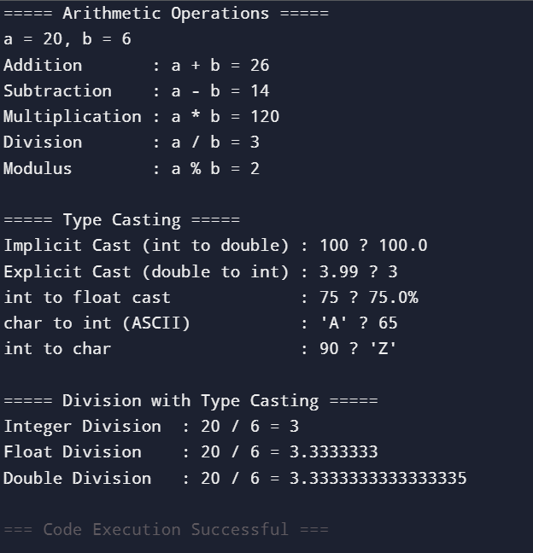

Logical Questions:

- What is the purpose of public static void main(String[] args) in Java?

- What is the difference between implicit and explicit type casting?

PRACTICAL -2
Aim: Create Java programs using control structures.
a. Create a Java program to find maximum of three numbers.
b. Create a Java program to find sum of digits of a number

Program/Implementation:

A: Maximum of Three Numbers

import java.util.Scanner;

public class MaxOfThree {
public static void main(String[] args) {

Scanner sc = new Scanner(System.in);

System.out.println("===== Find Maximum of Three Numbers =====");
System.out.print("Enter first number : ");
int a = sc.nextInt();

System.out.print("Enter second number : ");
int b = sc.nextInt();

System.out.print("Enter third number : ");
int c = sc.nextInt();

int max;

// Using if-else-if ladder
if (a >= b && a >= c) {
max = a;
} else if (b >= a && b >= c) {
max = b;
} else {
max = c;
}

System.out.println("\nNumbers entered : " + a + ", " + b + ", " + c);
System.out.println("Maximum number : " + max);

// Also demonstrating using nested if
System.out.println("\n--- Using Nested If ---");
int maxNested;
if (a > b) {
if (a > c) {
maxNested = a;
} else {
maxNested = c;
}
} else {
if (b > c) {
maxNested = b;
} else {
maxNested = c;
}
}
System.out.println("Maximum (Nested If) : " + maxNested);

// Also demonstrating using ternary operator
int maxTernary = (a > b) ? ((a > c) ? a : c) : ((b > c) ? b : c);
System.out.println("Maximum (Ternary) : " + maxTernary);

sc.close();
}
}

B: Sum of Digits of a Number
import java.util.Scanner;

public class SumOfDigits {
public static void main(String[] args) {

Scanner sc = new Scanner(System.in);

System.out.println("===== Sum of Digits of a Number =====");
System.out.print("Enter a number : ");
int number = sc.nextInt();

// Store original number for display
int original = number;

// Handle negative numbers
if (number < 0) {
number = -number;
}

int sum = 0;
int digit = 0;
int temp = number;

System.out.println("\n--- Step-by-Step Calculation ---");
System.out.printf("%-10s %-10s %-10s%n", "Number", "Digit", "Sum");
System.out.println("------------------------------");

// Using while loop to extract and sum digits
while (temp > 0) {
digit = temp % 10; // Extract last digit
sum = sum + digit; // Add digit to sum
System.out.printf("%-10d %-10d %-10d%n", temp, digit, sum);
temp = temp / 10; // Remove last digit
}

System.out.println("------------------------------");
System.out.println("Original Number : " + original);
System.out.println("Sum of Digits : " + sum);

// ---- Bonus: Using for loop approach ----
System.out.println("\n--- Using For Loop ---");
int sumFor = 0;
for (int n = number; n > 0; n /= 10) {
sumFor += n % 10;
}
System.out.println("Sum of Digits (for loop) : " + sumFor);

// ---- Bonus: Using String approach ----
System.out.println("\n--- Using String Method ---");
String numStr = Integer.toString(number);
int sumStr = 0;
for (int i = 0; i < numStr.length(); i++) {
sumStr += Character.getNumericValue(numStr.charAt(i));
}
System.out.println("Sum of Digits (String) : " + sumStr);

sc.close();
}
}

Output:
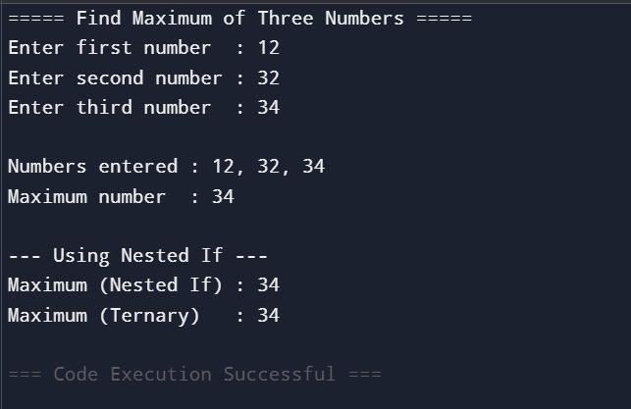
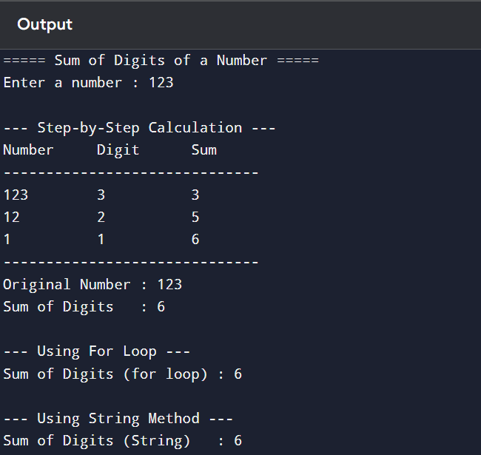

Logical Questions:

- What is the difference between if-else and ternary operator?

- How does % (modulus) operator help in extracting digits from a number?

PRACTICAL - 3
Aim: Create Java programs using arrays.
a. Create a Java program to find sum and average of array elements.
b. Create a Java program to perform addition of two matrices.

Program/Implementation:

A: Sum and Average of Array Elements
import java.util.Scanner;

public class SumAndAverage {
public static void main(String[] args) {

Scanner sc = new Scanner(System.in);

System.out.println("===== Sum and Average of Array Elements =====");
System.out.print("Enter the number of elements : ");
int n = sc.nextInt();

int[] arr = new int[n];

// Input array elements
System.out.println("Enter " + n + " elements :");
for (int i = 0; i < n; i++) {
System.out.print("Element [" + i + "] : ");
arr[i] = sc.nextInt();
}

// Display array
System.out.println("\n--- Array Elements ---");
System.out.print("Array : [ ");
for (int i = 0; i < n; i++) {
System.out.print(arr[i]);
if (i != n - 1) System.out.print(", ");
}
System.out.println(" ]");

// Calculate sum
int sum = 0;
System.out.println("\n--- Step-by-Step Sum Calculation ---");
for (int i = 0; i < n; i++) {
sum += arr[i];
System.out.println("After adding arr[" + i + "] = " + arr[i]
+ " → Running Sum = " + sum);
}

// Calculate average
double average = (double) sum / n;

// Find max and min as bonus
int max = arr[0];
int min = arr[0];
for (int i = 1; i < n; i++) {
if (arr[i] > max) max = arr[i];
if (arr[i] < min) min = arr[i];
}

// Final Results
System.out.println("\n========== Results ==========");
System.out.println("Number of Elements : " + n);
System.out.println("Sum of Elements : " + sum);
System.out.printf ("Average : %.2f%n", average);
System.out.println("Maximum Element : " + max);
System.out.println("Minimum Element : " + min);
System.out.println("=============================");

sc.close();
}
}

B: Addition of Two Matrices
import java.util.Scanner;

public class MatrixAddition {
public static void main(String[] args) {

Scanner sc = new Scanner(System.in);

System.out.println("===== Matrix Addition =====");
System.out.print("Enter number of rows : ");
int rows = sc.nextInt();
System.out.print("Enter number of columns : ");
int cols = sc.nextInt();

int[][] matA = new int[rows][cols];
int[][] matB = new int[rows][cols];
int[][] result = new int[rows][cols];

// Input Matrix A
System.out.println("\nEnter elements of Matrix A (" + rows + "x" + cols + ") :");
for (int i = 0; i < rows; i++) {
for (int j = 0; j < cols; j++) {
System.out.print("A[" + i + "][" + j + "] : ");
matA[i][j] = sc.nextInt();
}
}

// Input Matrix B
System.out.println("\nEnter elements of Matrix B (" + rows + "x" + cols + ") :");
for (int i = 0; i < rows; i++) {
for (int j = 0; j < cols; j++) {
System.out.print("B[" + i + "][" + j + "] : ");
matB[i][j] = sc.nextInt();
}
}

// Matrix Addition
for (int i = 0; i < rows; i++) {
for (int j = 0; j < cols; j++) {
result[i][j] = matA[i][j] + matB[i][j];
}
}

// Method to print a matrix neatly
System.out.println("\n========== Matrix A ==========");
printMatrix(matA, rows, cols);

System.out.println("\n========== Matrix B ==========");
printMatrix(matB, rows, cols);

System.out.println("\n====== Resultant Matrix (A + B) ======");
printMatrix(result, rows, cols);

// Show element-wise addition
System.out.println("\n--- Element-wise Addition ---");
for (int i = 0; i < rows; i++) {
for (int j = 0; j < cols; j++) {
System.out.println("A[" + i + "][" + j + "] + B[" + i + "][" + j + "] = "
+ matA[i][j] + " + " + matB[i][j] + " = " + result[i][j]);
}
}

sc.close();
}

// Helper method to print matrix in grid format
static void printMatrix(int[][] mat, int rows, int cols) {
for (int i = 0; i < rows; i++) {
System.out.print("| ");
for (int j = 0; j < cols; j++) {
System.out.printf("%4d ", mat[i][j]);
}
System.out.println("|");
}
}
}

Output:

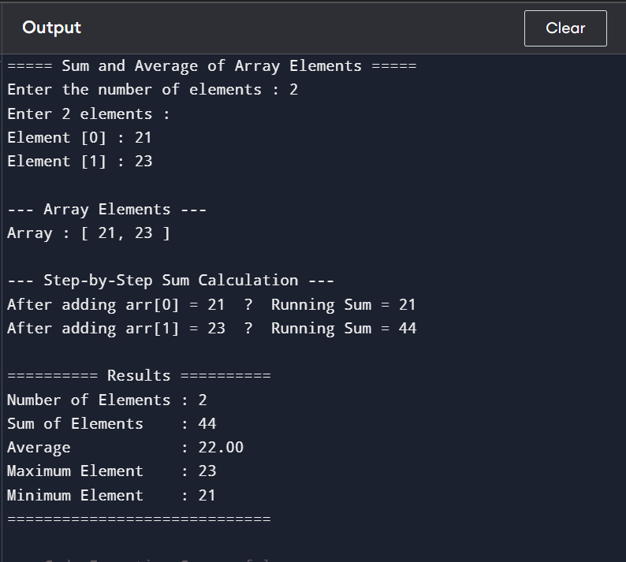

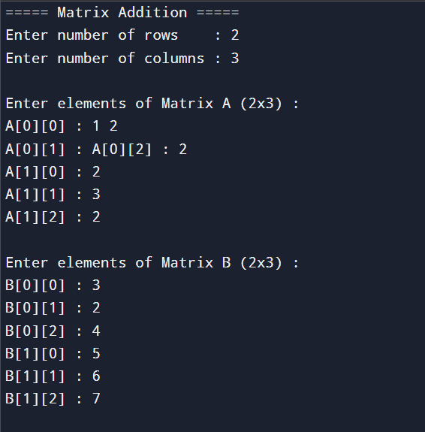
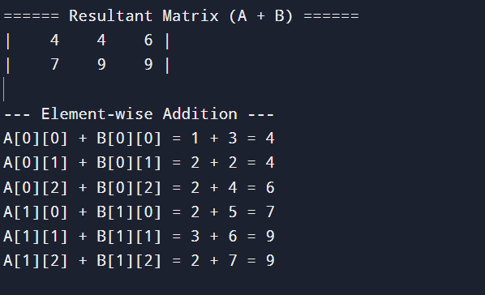

Logical Questions:

- What is the default value of an uninitialized integer array in Java?

- What is the difference between a 1D and 2D array?

PRACTICAL - 4
Aim: Create a Student class with fields and methods in Java program. Demonstrate object creation and method calling.

Program/Implementation:

import java.util.Scanner;

public class Student {

// ===== FIELDS (Instance Variables) =====
int rollNo;
String name;
String branch;
int age;
double marks[];
double percentage;
String grade;

// ===== CONSTRUCTOR (Default) =====
Student() {
rollNo = 0;
name = "Unknown";
branch = "Unknown";
age = 0;
marks = new double[5];
percentage = 0.0;
grade = "N/A";
}

// ===== CONSTRUCTOR (Parameterized) =====
Student(int rollNo, String name, String branch, int age, double[] marks) {
this.rollNo = rollNo;
this.name = name;
this.branch = branch;
this.age = age;
this.marks = marks;
this.percentage = calculatePercentage();
this.grade = calculateGrade();
}

// ===== METHOD: Calculate Percentage =====
double calculatePercentage() {
double total = 0;
for (double m : marks) {
total += m;
}
return total / marks.length;
}

// ===== METHOD: Calculate Grade =====
String calculateGrade() {
if (percentage >= 90) return "O (Outstanding)";
else if (percentage >= 75) return "A+ (Excellent)";
else if (percentage >= 60) return "A (Very Good)";
else if (percentage >= 50) return "B (Good)";
else if (percentage >= 40) return "C (Average)";
else return "F (Fail)";
}

// ===== METHOD: Display Student Details =====
void displayDetails() {
System.out.println("╔══════════════════════════════════════╗");
System.out.println("║ STUDENT DETAILS ║");
System.out.println("╠══════════════════════════════════════╣");
System.out.printf ("║ Roll No : %-24d║%n", rollNo);
System.out.printf ("║ Name : %-24s║%n", name);
System.out.printf ("║ Branch : %-24s║%n", branch);
System.out.printf ("║ Age : %-24d║%n", age);
System.out.println("╠══════════════════════════════════════╣");
System.out.println("║ MARKS DETAILS ║");
System.out.println("╠══════════════════════════════════════╣");
String[] subjects = {"Maths ", "Science", "English", "History", "CS "};
for (int i = 0; i < marks.length; i++) {
System.out.printf("║ %s : %-24.1f║%n", subjects[i], marks[i]);
}
System.out.println("╠══════════════════════════════════════╣");
System.out.printf ("║ Percentage: %-24.2f║%n", percentage);
System.out.printf ("║ Grade : %-24s║%n", grade);
System.out.println("╚══════════════════════════════════════╝");
}

// ===== METHOD: Update Marks =====
void updateMarks(double[] newMarks) {
this.marks = newMarks;
this.percentage = calculatePercentage();
this.grade = calculateGrade();
System.out.println("✔ Marks updated successfully for " + name);
}

// ===== METHOD: Check Pass or Fail =====
void checkResult() {
boolean passed = true;
System.out.println("\n--- Result Card for " + name + " ---");
String[] subjects = {"Maths", "Science", "English", "History", "CS"};
for (int i = 0; i < marks.length; i++) {
String status = (marks[i] >= 40) ? "PASS" : "FAIL";
if (marks[i] < 40) passed = false;
System.out.printf("%-10s : %5.1f [%s]%n", subjects[i], marks[i], status);
}
System.out.println("-------------------------------");
System.out.println("Overall Result : " + (passed ? "✔ PASSED" : "✘ FAILED"));
}

// ===== METHOD: Compare Two Students =====
void compareWith(Student other) {
System.out.println("\n--- Comparing Students ---");
System.out.printf("%-12s : %-15s vs %-15s%n", "Name",
this.name, other.name);
System.out.printf("%-12s : %-15.2f vs %-15.2f%n", "Percentage",
this.percentage, other.percentage);
if (this.percentage > other.percentage) {
System.out.println("🏆 " + this.name + " scored higher!");
} else if (other.percentage > this.percentage) {
System.out.println("🏆 " + other.name + " scored higher!");
} else {
System.out.println("🏆 Both students scored equally!");
}
}

// ===== MAIN METHOD =====
public static void main(String[] args) {

System.out.println("╔══════════════════════════════════════╗");
System.out.println("║ STUDENT CLASS DEMONSTRATION ║");
System.out.println("╚══════════════════════════════════════╝");

// --- Object 1: Using Parameterized Constructor ---
System.out.println("\n>>> Creating Student 1 using Parameterized Constructor...");
double[] marks1 = {88.0, 92.0, 78.0, 85.0, 95.0};
Student s1 = new Student(101, "Rahul Sharma", "Computer Science", 20, marks1);

// --- Object 2: Using Parameterized Constructor ---
System.out.println(">>> Creating Student 2 using Parameterized Constructor...");
double[] marks2 = {72.0, 65.0, 80.0, 55.0, 70.0};
Student s2 = new Student(102, "Priya Patel", "Information Tech", 21, marks2);

// --- Object 3: Using Default Constructor then setting values ---
System.out.println(">>> Creating Student 3 using Default Constructor...");
Student s3 = new Student();
s3.rollNo = 103;
s3.name = "Amit Verma";
s3.branch = "Electronics";
s3.age = 20;
s3.marks = new double[]{35.0, 42.0, 38.0, 45.0, 30.0};
s3.percentage = s3.calculatePercentage();
s3.grade = s3.calculateGrade();

// ---- Calling displayDetails() ----
System.out.println("\n========== Displaying All Students ==========");
s1.displayDetails();
System.out.println();
}}

Output

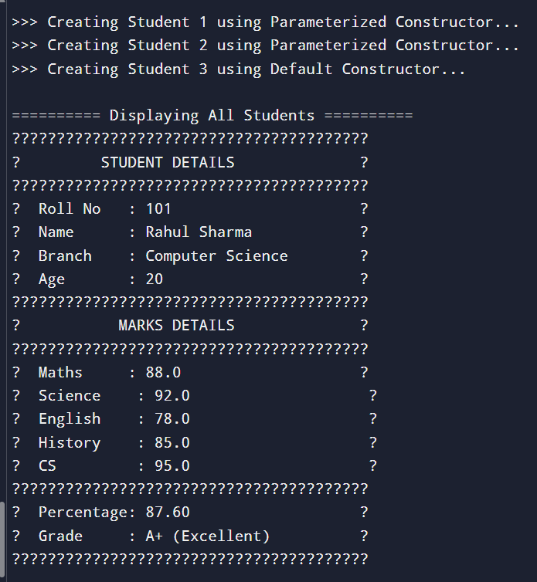

Logical Questions

- What is the difference between a class and an object?

- What is the role of this keyword in a constructor?

PRACTICAL - 5
Aim: Create Java programs using constructor, this and static keywords.
a. Create a Java program to demonstrate default and parameterized constructors and the use of ‘this’ keyword.
b. Create a Java program to demonstrate different uses of ‘static’ keyword.

Program/Implementation:

A: Constructors & this Keyword

public class BankAccount {

// ===== FIELDS =====
int accountNo;
String holderName;
String accountType;
double balance;
String ifscCode;

// Static field to auto-generate account numbers
static int nextAccountNo = 1001;

// ===== DEFAULT CONSTRUCTOR =====
BankAccount() {
this.accountNo = nextAccountNo++;
this.holderName = "Unknown";
this.accountType = "Savings";
this.balance = 0.0;
this.ifscCode = "BANK0000001";
System.out.println("✔ Default Constructor called → Account No: " + this.accountNo);
}

// ===== PARAMETERIZED CONSTRUCTOR 1 (name only) =====
BankAccount(String holderName) {
this(); // Calls default constructor using 'this'
this.holderName = holderName; // Overrides default name
System.out.println("✔ Constructor(name) called → Holder: " + this.holderName);
}

// ===== PARAMETERIZED CONSTRUCTOR 2 (name + balance) =====
BankAccount(String holderName, double balance) {
this(holderName); // Calls Constructor 1 using 'this'
this.balance = balance;
System.out.println("✔ Constructor(name,bal) called → Balance: " + this.balance);
}

// ===== PARAMETERIZED CONSTRUCTOR 3 (all fields) =====
BankAccount(String holderName, String accountType, double balance, String ifscCode) {
this(holderName, balance); // Calls Constructor 2 using 'this'
this.accountType = accountType;
this.ifscCode = ifscCode;
System.out.println("✔ Constructor(all) called → Type: " + this.accountType);
}

// ===== METHOD: Deposit using 'this' =====
BankAccount deposit(double amount) {
if (amount > 0) {
this.balance += amount;
System.out.println(" [Deposit] +" + amount
+ " → New Balance: " + this.balance);
} else {
System.out.println(" ✘ Invalid deposit amount!");
}
return this; // Returns current object → enables method chaining
}

// ===== METHOD: Withdraw using 'this' =====
BankAccount withdraw(double amount) {
if (amount > 0 && amount <= this.balance) {
this.balance -= amount;
System.out.println(" [Withdraw] -" + amount
+ " → New Balance: " + this.balance);
} else {
System.out.println(" ✘ Insufficient balance or invalid amount!");
}
return this; // Returns current object → enables method chaining
}

// ===== METHOD: Display Account Details =====
void displayAccount() {
System.out.println("┌─────────────────────────────────────┐");
System.out.println("│ ACCOUNT DETAILS │");
System.out.println("├─────────────────────────────────────┤");
System.out.printf ("│ Account No : %-20d│%n", this.accountNo);
System.out.printf ("│ Holder Name : %-20s│%n", this.holderName);
System.out.printf ("│ Account Type : %-20s│%n", this.accountType);
System.out.printf ("│ Balance : %-20.2f│%n", this.balance);
System.out.printf ("│ IFSC Code : %-20s│%n", this.ifscCode);
System.out.println("└─────────────────────────────────────┘");
}

// ===== METHOD: Compare using 'this' =====
void compareBalance(BankAccount other) {
System.out.println("\n--- Balance Comparison ---");
System.out.println(" " + this.holderName + " : ₹" + this.balance);
System.out.println(" " + other.holderName + " : ₹" + other.balance);
if (this.balance > other.balance)
System.out.println(" 🏆 " + this.holderName + " has higher balance.");
else if (this.balance < other.balance)
System.out.println(" 🏆 " + other.holderName + " has higher balance.");
else
System.out.println(" 🏆 Both have equal balance.");
}

// ===== MAIN METHOD =====
public static void main(String[] args) {

System.out.println("╔══════════════════════════════════════════╗");
System.out.println("║ CONSTRUCTOR & this KEYWORD DEMO ║");
System.out.println("╚══════════════════════════════════════════╝");

// --- Default Constructor ---
System.out.println("\n>>> Object 1: Default Constructor");
BankAccount acc1 = new BankAccount();
acc1.displayAccount();

// --- Constructor with name only ---
System.out.println("\n>>> Object 2: Constructor(name)");
BankAccount acc2 = new BankAccount("Rahul Sharma");
acc2.displayAccount();

// --- Constructor with name + balance ---
System.out.println("\n>>> Object 3: Constructor(name, balance)");
BankAccount acc3 = new BankAccount("Priya Patel", 15000.00);
acc3.displayAccount();

// --- Full Parameterized Constructor ---
System.out.println("\n>>> Object 4: Constructor(all fields)");
BankAccount acc4 = new BankAccount("Amit Verma", "Current",
50000.00, "BANK0001234");
acc4.displayAccount();

// --- 'this' for Method Chaining ---
System.out.println("\n>>> Demonstrating Method Chaining using 'this'");
System.out.println("Account: " + acc3.holderName);
acc3.deposit(5000).deposit(3000).withdraw(2000).withdraw(500);

System.out.println("\nAfter Chaining:");
acc3.displayAccount();

// --- 'this' for Object Comparison ---
acc3.compareBalance(acc4);
}
}
}

B: static Keyword

public class Counter {

static int totalObjects = 0;
static String bankName = "Java National Bank";
int id;
String ownerName;
double balance;

// ===== STATIC BLOCK =====
// Runs ONCE when class is loaded into memory
static {
System.out.println("╔══════════════════════════════════════╗");
System.out.println("║ static KEYWORD DEMO ║");
System.out.println("╚══════════════════════════════════════╝");
System.out.println(">>> Static Block executed!");
System.out.println(" Bank Name : " + bankName);
System.out.println(" System ready. Waiting for objects...\n");
}

// ===== CONSTRUCTOR =====
Counter(String ownerName, double balance) {
totalObjects++; // Increment shared static counter
this.id = totalObjects;
this.ownerName = ownerName;
this.balance = balance;
System.out.println(" [+] Object " + this.id + " created → " + this.ownerName);
}

// ===== INSTANCE METHOD =====
// Can access both static and instance fields
void displayInfo() {
System.out.printf(" ID: %-4d | Owner: %-15s | Balance: ₹%-10.2f | Bank: %s%n",
id, ownerName, balance, bankName);
}

// ===== STATIC METHOD =====
// Can ONLY access static fields — cannot use 'this'
static void displayBankInfo() {
System.out.println("\n--- Bank Information ---");
System.out.println(" Bank Name : " + bankName);
System.out.println(" Total Accounts : " + totalObjects);
System.out.println("------------------------");
}

// ===== STATIC METHOD: Change Bank Name =====
static void setBankName(String name) {
bankName = name;
System.out.println(" ✔ Bank name updated to: " + bankName);
}

// ===== STATIC UTILITY METHOD (no object needed) =====
static double calculateInterest(double principal, double rate, int years) {
return (principal * rate * years) / 100;
}

static double calculateCompoundInterest(double principal, double rate, int years) {
return principal * Math.pow((1 + rate / 100), years) - principal;
}

// ===== MAIN METHOD =====
public static void main(String[] args) {

// --- Static field accessed WITHOUT object ---
System.out.println(">>> Accessing static field without object:");
System.out.println(" Total Objects = " + Counter.totalObjects);
System.out.println(" Bank Name = " + Counter.bankName);

// --- Calling static method WITHOUT object ---
System.out.println("\n>>> Calling static method without object:");
Counter.displayBankInfo();

// --- Creating Objects ---
System.out.println(">>> Creating Accounts:");
Counter c1 = new Counter("Rahul Sharma", 25000.00);
Counter c2 = new Counter("Priya Patel", 42000.50);
Counter c3 = new Counter("Amit Verma", 15750.75);

// --- Static field reflects ALL objects ---
System.out.println("\n>>> Static field 'totalObjects' after creating 3 accounts:");
System.out.println(" Via Class : Counter.totalObjects = " + Counter.totalObjects);
System.out.println(" Via Object : c1.totalObjects = " + c1.totalObjects);
System.out.println(" (Both show same value — only ONE copy exists)\n");

// --- Display all accounts ---
System.out.println(">>> All Account Details:");
c1.displayInfo();
c2.displayInfo();
c3.displayInfo();

// --- Changing static field affects all objects ---
System.out.println("\n>>> Changing Bank Name via static method:");
Counter.setBankName("Bharat Digital Bank");
System.out.println(" After change — all accounts reflect new bank name:");
c1.displayInfo();
c2.displayInfo();
c3.displayInfo();

// --- Bank info after all objects ---
Counter.displayBankInfo();

// --- Static Utility Methods (no object needed) ---
System.out.println(">>> Static Utility Methods (Interest Calculator):");
double principal = 50000;
double rate = 8.5;
int years = 3;

double si = Counter.calculateInterest(principal, rate, years);
double ci = Counter.calculateCompoundInterest(principal, rate, years);

System.out.println(" Principal : ₹" + principal);
System.out.println(" Rate : " + rate + "% per annum");
System.out.println(" Years : " + years);
System.out.printf (" Simple Interest : ₹%.2f%n", si);
System.out.printf (" Compound Interest : ₹%.2f%n", ci);

// --- Summary of static vs instance ---
System.out.println("\n╔══════════════════════════════════════════════╗");
System.out.println("║ static vs instance SUMMARY ║");
System.out.println("╠══════════════════════════════════════════════╣");
System.out.println("║ static field → shared by ALL objects ║");
System.out.println("║ instance field → unique to EACH object ║");
System.out.println("║ static method → called via Class name ║");
System.out.println("║ instance method→ called via object ║");
System.out.println("║ static block → runs ONCE on class load ║");
System.out.println("╚══════════════════════════════════════════════╝");
}
}

Output:
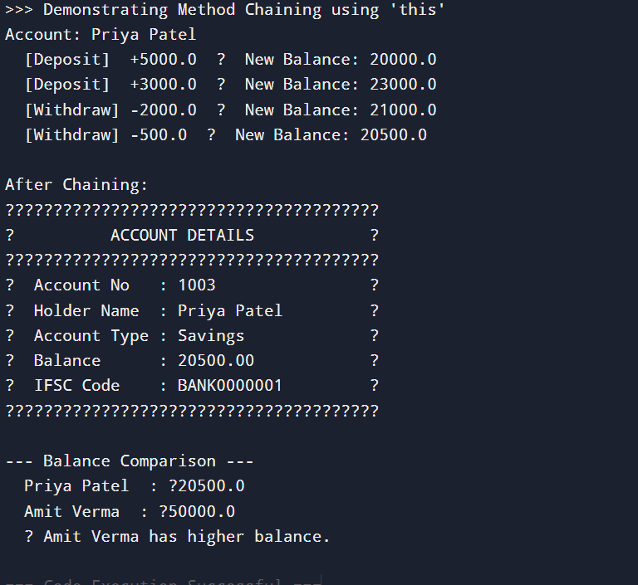

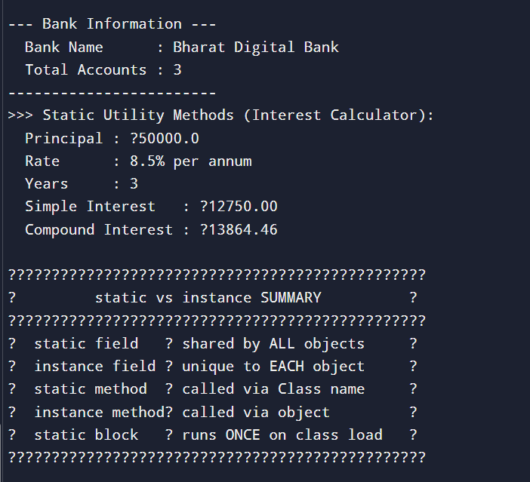

Logical Questions:

- What is constructor chaining and how is it achieved using this()?

- What is the difference between a static method and an instance method?

PRACTICAL - 6
Aim: Create a Java program to demonstrate method overloading.

Program/Implementation:

public class MethodOverloading {

// 1. Overloading by NUMBER of parameters
int add(int a, int b) { return a + b; }
int add(int a, int b, int c) { return a + b + c; }

// 2. Overloading by TYPE of parameters
double add(double a, double b) { return a + b; }
String add(String a, String b) { return a + b; }

public static void main(String[] args) {

MethodOverloading obj = new MethodOverloading();

// By number of parameters
System.out.println("add(10, 20) = " + obj.add(10, 20));
System.out.println("add(10, 20, 30) = " + obj.add(10, 20, 30));

// By type of parameters
System.out.println("add(10.5, 20.5) = " + obj.add(10.5, 20.5));
System.out.println("add(Hello, World) = " + obj.add("Hello ", "World"));
}
}
OUTPUT:

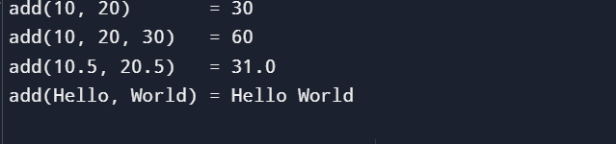

Logical Questions:

- Can two overloaded methods differ only in return type?

- What is the difference between method overloading and method overriding?

PRACTICAL - 7
Aim: Create a Java program to perform various String operations of using built-in String methods.

Program/Implementation:

public class StringOperations {
public static void main(String[] args) {

String s1 = "Hello World";
String s2 = " Java Programming ";
String s3 = "hello world";

// 1. Basic Info
System.out.println("Original String : " + s1);
System.out.println("Length : " + s1.length());
System.out.println("charAt(4) : " + s1.charAt(4));
System.out.println("indexOf('o') : " + s1.indexOf('o'));
System.out.println("lastIndexOf('o') : " + s1.lastIndexOf('o'));

// 2. Case Conversion
System.out.println("\ntoUpperCase() : " + s1.toUpperCase());
System.out.println("toLowerCase() : " + s1.toLowerCase());

// 3. Trimming & Replacing
System.out.println("\nBefore trim : \"" + s2 + "\"");
System.out.println("After trim() : \"" + s2.trim() + "\"");
System.out.println("replace(l, r) : " + s1.replace('l', 'r'));
System.out.println("replaceAll(o, 0) : " + s1.replaceAll("o", "0"));

// 4. Substring & Splitting
System.out.println("\nsubstring(6) : " + s1.substring(6));
System.out.println("substring(0, 5) : " + s1.substring(0, 5));
String[] words = s1.split(" ");
System.out.print("split(\" \") : ");
for (String w : words) System.out.print("[" + w + "] ");
System.out.println();

// 5. Comparison
System.out.println("\nequals(s3) : " + s1.equals(s3));
System.out.println("equalsIgnoreCase(s3): " + s1.equalsIgnoreCase(s3));
System.out.println("compareTo(s3) : " + s1.compareTo(s3));
System.out.println("startsWith(Hello) : " + s1.startsWith("Hello"));
System.out.println("endsWith(World) : " + s1.endsWith("World"));
System.out.println("contains(World) : " + s1.contains("World"));

// 6. Conversion
System.out.println("\nvalueOf(100) : " + String.valueOf(100));
System.out.println("valueOf(true) : " + String.valueOf(true));
System.out.println("toCharArray() : ");
for (char c : s1.toCharArray()) System.out.print(c + " ");
System.out.println();

// 7. Concatenation & isEmpty
String s4 = s1.concat(" - Java");
System.out.println("\nconcat() : " + s4);
System.out.println("isEmpty() : " + s1.isEmpty());
System.out.println("isEmpty(empty str) : " + "".isEmpty());
}
}
OUTPUT:
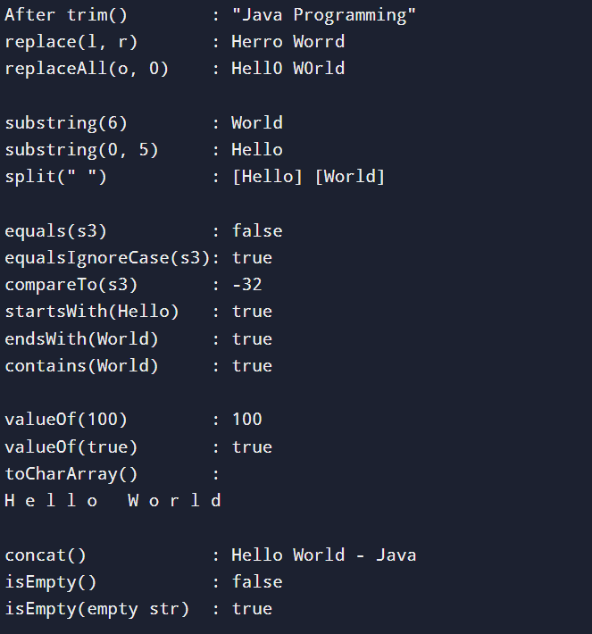
Logical Questions:

- What is the difference between equals() and == when comparing strings?

- What does trim() do and when is it useful?
PRACTICAL - 8
Aim: Create a Java program to accept input using the Scanner class, store values and demonstrate autoboxing and unboxing

Program/Implementation:
import java.util.Scanner;
import java.util.ArrayList;

public class AutoboxingDemo {
public static void main(String[] args) {

Scanner sc = new Scanner(System.in);

// ---- Accept Input ----
System.out.print("Enter name : ");
String name = sc.nextLine();

System.out.print("Enter age : ");
int age = sc.nextInt();

System.out.print("Enter marks : ");
double marks = sc.nextDouble();

System.out.print("Enter pincode : ");
long pincode = sc.nextLong();

// ---- Autoboxing: primitive → Wrapper ----
Integer boxedAge = age; // int → Integer
Double boxedMarks = marks; // double → Double
Long boxedPincode = pincode; // long → Long
Boolean boxedPass = marks >= 40; // boolean → Boolean

System.out.println("\n--- Autoboxing (primitive → Wrapper) ---");
System.out.println("int → Integer : " + boxedAge);
System.out.println("double → Double : " + boxedMarks);
System.out.println("long → Long : " + boxedPincode);
System.out.println("boolean → Boolean : " + boxedPass);

// ---- Unboxing: Wrapper → primitive ----
int unboxedAge = boxedAge; // Integer → int
double unboxedMarks = boxedMarks; // Double → double

System.out.println("\n--- Unboxing (Wrapper → primitive) ---");
System.out.println("Integer → int : " + unboxedAge);
System.out.println("Double → double : " + unboxedMarks);

// ---- Wrapper Utility Methods ----
System.out.println("\n--- Wrapper Utility Methods ---");
System.out.println("Integer.MAX_VALUE : " + Integer.MAX_VALUE);
System.out.println("Integer.MIN_VALUE : " + Integer.MIN_VALUE);
System.out.println("Integer.toBinary() : " + Integer.toBinaryString(age));
System.out.println("Integer.toHex() : " + Integer.toHexString(age));
System.out.println("Double.parseDouble : " + Double.parseDouble("3.14"));
System.out.println("Integer.parseInt : " + Integer.parseInt("100"));

// ---- ArrayList (requires Wrapper — shows autoboxing in collections) ----
System.out.println("\n--- Autoboxing in ArrayList ---");
ArrayList<Integer> marksList = new ArrayList<>();
marksList.add(85); // autoboxing
marksList.add(90);
marksList.add(78);
marksList.add((int) marks); // explicit cast then autobox

System.out.print("Marks List : ");
int total = 0;
for (int m : marksList) { // unboxing in loop
System.out.print(m + " ");
total += m; // unboxing for arithmetic
}
System.out.println("\nTotal : " + total);
System.out.println("Average : " + (double) total / marksList.size());

// ---- Summary ----
System.out.println("\n--- Student Summary ---");
System.out.println("Name : " + name);
System.out.println("Age : " + unboxedAge);
System.out.println("Marks : " + unboxedMarks);
System.out.println("Pincode : " + pincode);
System.out.println("Result : " + (boxedPass ? "PASS" : "FAIL"));

sc.close();
}
}

OUTPUT:
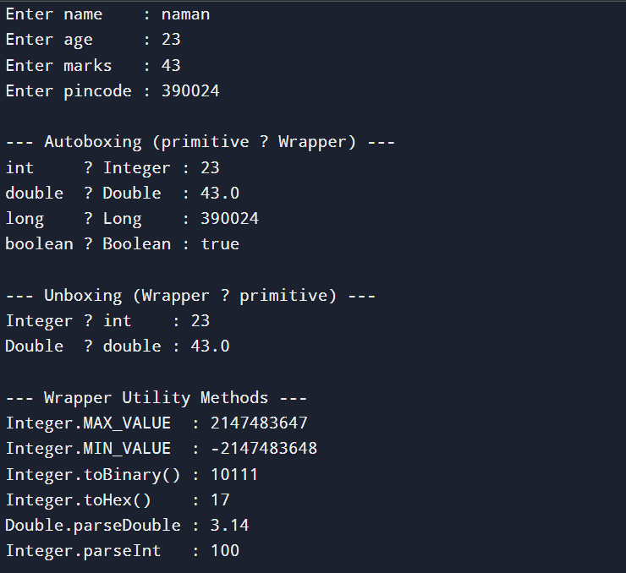
Logical Questions:

- What is the difference between autoboxing and unboxing?

- Why does ArrayList require wrapper classes instead of primitive types?

PRACTICAL - 9
Aim: Create a Java program to demonstrate single and multilevel inheritance.
Program/Implementation:

// ── Base Class ──
class Animal {
String name;

Animal(String name) {
this.name = name;
System.out.println("Animal: " + name);
}

void eat() { System.out.println(name + " is eating."); }
void sleep() { System.out.println(name + " is sleeping."); }
}

// ── Single Inheritance: Dog extends Animal ──
class Dog extends Animal {
String breed;

Dog(String name, String breed) {
super(name);
this.breed = breed;
System.out.println("Dog breed: " + breed);
}

void bark() { System.out.println(name + " is barking."); }
}

// ── Multilevel Inheritance: Puppy extends Dog extends Animal ──
class Puppy extends Dog {
int age;

Puppy(String name, String breed, int age) {
super(name, breed);
this.age = age;
System.out.println("Puppy age: " + age);
}

void weep() { System.out.println(name + " is weeping."); }
}

public class InheritanceDemo {
public static void main(String[] args) {

System.out.println("-- Single Inheritance --");
Dog dog = new Dog("Bruno", "Labrador");
dog.eat();
dog.sleep();
dog.bark();

System.out.println("\n-- Multilevel Inheritance --");
Puppy pup = new Puppy("Tommy", "Poodle", 2);
pup.eat();
pup.bark();
pup.weep();
}
}

OUTPUT:
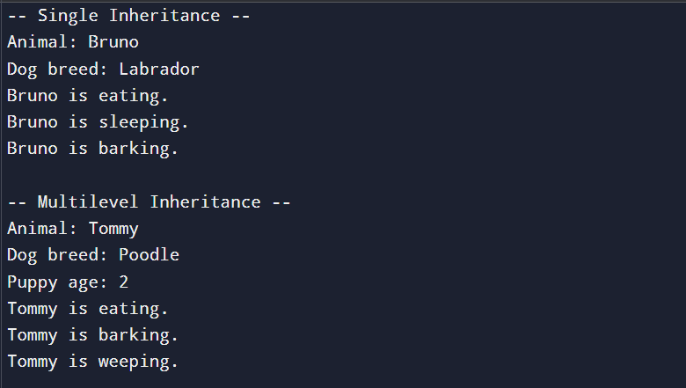

Logical Questions:

- What is the difference between single and multilevel inheritance?

- What is the role of super keyword in inheritance?
PRACTICAL - 10
Aim: Write a Java practical to declare a 1D array of 10 integers, accept values from the user, and find the maximum, minimum, sum, and average of all elements.

Source Code:
import java.util.Scanner;

public class ArrayOperations {
public static void main(String[] args) {

Scanner sc = new Scanner(System.in);
int[] arr = new int[10];

System.out.println("Enter 10 integers:");
for (int i = 0; i < 10; i++) {
System.out.print("Element [" + i + "] : ");
arr[i] = sc.nextInt();
}

int max = arr[0], min = arr[0], sum = 0;

for (int i = 0; i < 10; i++) {
if (arr[i] > max) max = arr[i];
if (arr[i] < min) min = arr[i];
sum += arr[i];
}

double avg = (double) sum / 10;
System.out.println("\n-- Results --");
System.out.println("Maximum : " + max);
System.out.println("Minimum : " + min);
System.out.println("Sum : " + sum);
System.out.println("Average : " + avg);
sc.close();
}
}

OUTPUT:
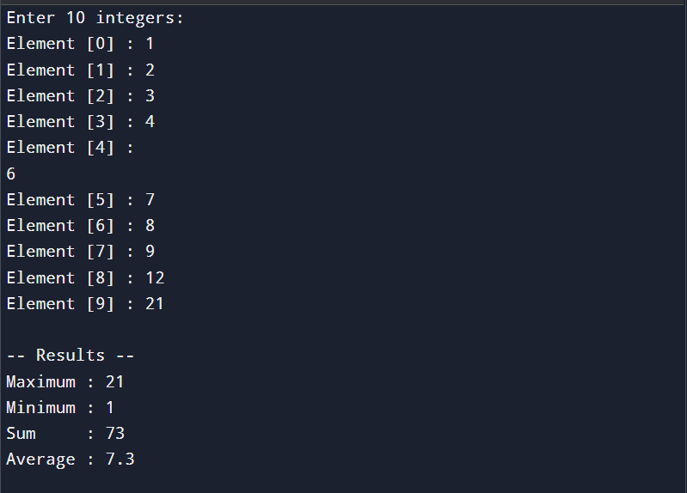

Logical Questions:

- Why is arr[0] used to initialize max and min instead of 0?

- Why is (double) cast needed when calculating the average of integers?

PRACTICAL – 11
Aim: Write a Java practical to create a Student class with fields name, roll number, and marks using a parameterized constructor and a display() method to print details of multiple student objects.

Source Code:
public class Student {

String name;
int rollNo;
double marks;

Student(String name, int rollNo, double marks) {
this.name = name;
this.rollNo = rollNo;
this.marks = marks;
}

void display() {
System.out.println("Roll No : " + rollNo);
System.out.println("Name : " + name);
System.out.println("Marks : " + marks);
System.out.println("Grade : " + (marks >= 75 ? "A" : marks >= 60 ? "B" : marks >= 40 ? "C" : "F"));
System.out.println("----------------------------");
}

public static void main(String[] args) {

Student s1 = new Student("Rahul Sharma", 101, 88.5);
Student s2 = new Student("Priya Patel", 102, 63.0);
Student s3 = new Student("Amit Verma", 103, 35.0);

System.out.println("-- Student Details --");
s1.display();
s2.display();
s3.display();
}
}
OUTPUT:

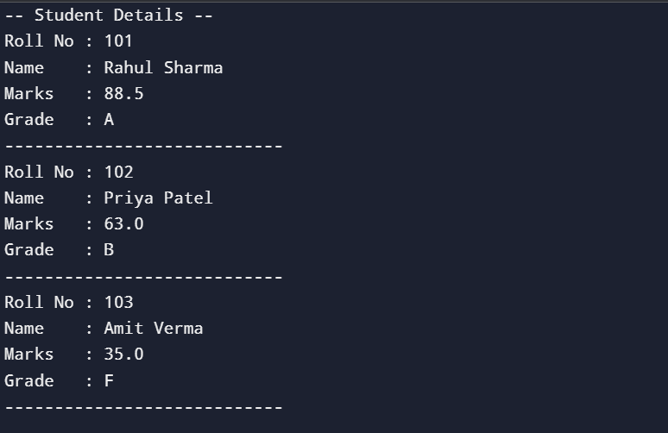Logical Questions:

- What is the advantage of a parameterized constructor over a default constructor?

- Can a class have multiple constructors in Java?

PRACTICAL – 12
Aim: Write a Java practical to demonstrate inheritance and method overriding by creating a parent class Animal and a child class Dog that overrides the sound() method using the super keyword.
Source Code:
class Animal {
String name;
Animal(String name) {
this.name = name;
}
void sound() {
System.out.println(name + " makes a generic sound.");
}
void eat() {
System.out.println(name + " is eating.");
}
}

class Dog extends Animal {
String breed;
Dog(String name, String breed) {
super(name);
this.breed = breed;
}

@Override
void sound() {
super.sound(); // Calls parent method
System.out.println(name + " barks: Woof Woof!"); // Overridden behavior
}
}

public class OverridingDemo {
public static void main(String[] args) {
Animal a = new Animal("Animal");
Dog d = new Dog("Bruno", "Labrador");
System.out.println("-- Parent Class --");
a.sound();
a.eat();
System.out.println("\n-- Child Class (Overriding) --");
d.sound();
d.eat();
}
}

OUTPUT:



Logical Questions:

- What is the difference between @Override annotation and without it?

- What happens when super.sound() is called inside the child class?

PRACTICAL – 13
Aim: Write a Java practical to demonstrate the Collections Framework by creating an ArrayList of student names to perform add, remove, and search operations and a HashSet to store and display unique roll numbers using a for-each loop.

Source Code:
import java.util.ArrayList;
import java.util.HashSet;

public class CollectionsDemo {
public static void main(String[] args) {

// ── ArrayList of Student Names ──
ArrayList<String> students = new ArrayList<>();

// Add
students.add("Rahul Sharma");
students.add("Priya Patel");
students.add("Amit Verma");
students.add("Neha Singh");

System.out.println("-- ArrayList --");
System.out.println("Students : " + students);

// Remove
students.remove("Amit Verma");
System.out.println("After Remove: " + students);

// Search
System.out.println("Contains Priya? : " + students.contains("Priya Patel"));
System.out.println("Index of Neha : " + students.indexOf("Neha Singh"));

// For-each loop
System.out.println("\nAll Students:");
for (String s : students)
System.out.println(" " + s);

// ── HashSet of Roll Numbers ──
HashSet<Integer> rollNos = new HashSet<>();

rollNos.add(101);
rollNos.add(102);
rollNos.add(103);
rollNos.add(101); // duplicate — will be ignored
rollNos.add(102); // duplicate — will be ignored

System.out.println("\n-- HashSet (unique roll numbers) --");
System.out.println("Roll Numbers:");
for (int r : rollNos)
System.out.println(" " + r);

System.out.println("Total Unique: " + rollNos.size());
}
}
OUTPUT:
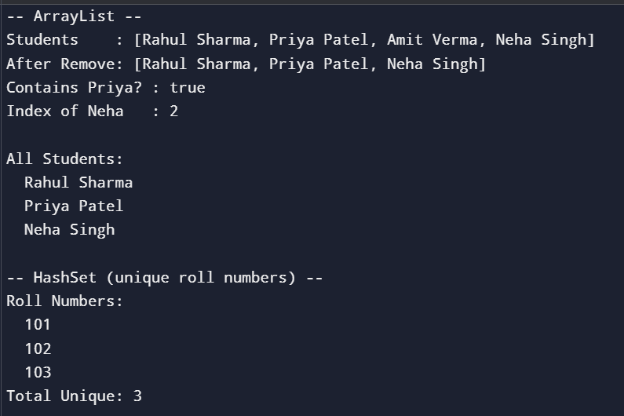

Logical Questions:

- What is the difference between ArrayList and HashSet?

- Why does HashSet not allow duplicate values?

PRACTICAL – 14
Aim: Write a Java practical to calculate the percentage of a student based on marks of 5 subjects and display the corresponding grade using if-else ladder control structure.
Source Code:
import java.util.Scanner;

public class StudentGrade {
public static void main(String[] args) {

Scanner sc = new Scanner(System.in);
int[] marks = new int[5];
String[] subjects = {"Maths", "Science", "English", "History", "CS"};

System.out.println("Enter marks for 5 subjects:");
for (int i = 0; i < 5; i++) {
System.out.print(subjects[i] + " : ");
marks[i] = sc.nextInt();
}

int sum = 0;
for (int m : marks) sum += m;
double percentage = sum / 5.0;

String grade;
if (percentage >= 90) grade = "O - Outstanding";
else if (percentage >= 75) grade = "A - Excellent";
else if (percentage >= 60) grade = "B - Very Good";
else if (percentage >= 50) grade = "C - Good";
else if (percentage >= 40) grade = "D - Average";
else grade = "F - Fail";

System.out.println("\n-- Result --");
System.out.println("Total : " + sum + " / 500");
System.out.printf ("Percentage : %.2f%%%n", percentage);
System.out.println("Grade : " + grade);
sc.close();
}
}
OUTPUT:

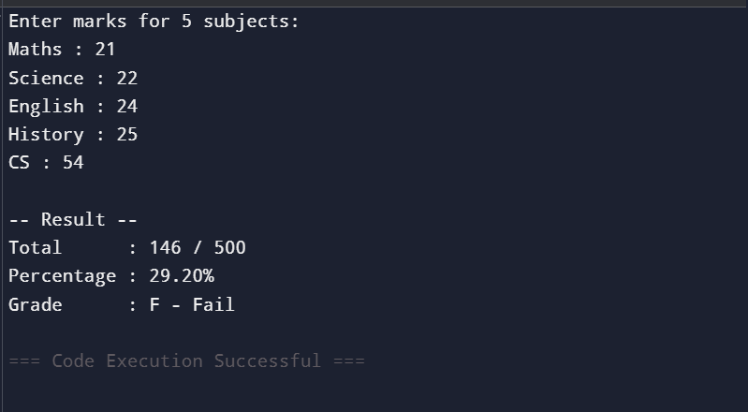Logical Questions:

- Why is sum / 5.0 used instead of sum / 5 for percentage?

- What is the difference between if-else ladder and switch statement?

